DAIRY FLAT SCHOOL AGRICULTURAL DAY 2019

**Mystery Seed Plant**

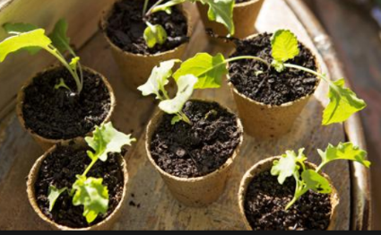This year we are trailling growing a mystery seed in a decorated pot.

**Instructions-**

* You will be given a mystery seed and a small jiffy growing pot. (note you’ll need your own potting mix)

You will need to come and pick them up from Room 1 before or after school in Term 3 –Date to be advised.

Cost-$2

First plant in given jiffy pot

Decorate a larger pot to compliment growing plant eg- **if** a sunflower-yellow pot covered in suns, bean plant- trellis with Jack climbing up etc

Replant into your own larger decorated pot.

Bring to school on Ag day morning- Saturday 19th October, ready for judging.

**JUDGING CRITERIA**

1. Must be grown from school provided seed
2. Growing container **must** be decorated tocompliment

your growing plant eg- **if** a sunflower pot could be covered in suns

1. Judging will be based on health of plant, imagination used to decorated pot.

Handy hint- find out what you plant is- App- Indigo Plant Recognition

The **Mystery Seed Plant** is to be brought to school and placed in the allocated area before 9am on Ag Day for judging.

You will need to display your Ag Day number on your exhibit (these numbers will be given to you prior to Ag Day).